**Part 01**

If we’re bearish we want to be looking for up closed candles, it will likely be sensitive and give some sort of displacement

The PM trend is a really nice time to trade, especially on the LTF charts

Once we break down below the daily up closed candle, note that we need to BREAK below it, not a slow drop, we leave behind imbalance, that’s when we immediately start looking at the last up closed candle prior to the break down, the bearish order block

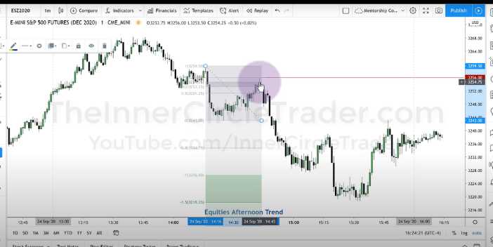

Our target is the projected range, measure the last swing up and project that down. Use the standard deviations

And of course, after watching the core content we know that the projections need to line up with an PD array